**If you don't have SQL server 2008. Please follow**   
  
Step-1.  
Please Download SQL server 2008.

* 1. <http://www.microsoft.com/en-us/download/details.aspx?id=1695>
  2. OR <https://1drv.ms/u/s!ApqzQIEDs_C5jdIolRxEYIdw672XXw> SQLEXP322_x86
  3. OR <https://1drv.ms/u/s!ApqzQIEDs_C5jdInLvjGuTGMXcXA2g> SQLEXP_x64

Step-2  
and Follow how to install it on your machine.  
<https://www.youtube.com/watch?v=_PJXFcRPKFc> SQL 2008  
<https://www.youtube.com/watch?v=8WAdeP5YREo> SQL 2008 R2  
**-----------------------------------------------------------------------------------**

**How to Setup Database script into SQL Server 2008**

Requirement _____________________________________________________________

* **Visual studio 2013 – up-to** target Framework="4.5"
* **MSSQL server 2008 – up-to**

**Step**: 1

How to Setup Database 🡪 [**Full youtube Video**](https://www.youtube.com/watch?v=yBhNP9Z23U4)

* Open SQL server 2008
* Create a New Database in your SQL Server 2008 DB Name is = “**RestPOS**”   
  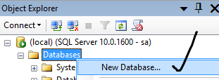
* Right Click on **RestPOS** DB select - > New Query   
  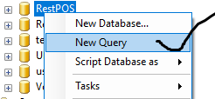

[YouTube Official Video] 🡪 [**How to import sql database script**](https://www.youtube.com/watch?v=yBhNP9Z23U4)

1. Copy all text/Script from '**RestPOS.sql**' file (Open with note pad) Copy all code and paste into **New Query** Panel. and Press **F5 or Execute**

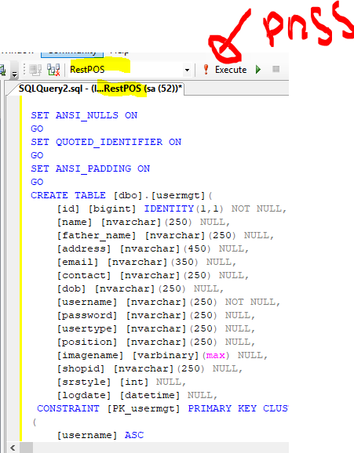

Database Setup is done!

# How to Support SQL server Database to your Native language (**optional**)

Open your SQL Database -> Select RestPOS DB -> Right click -> Select a page as **Options** tab

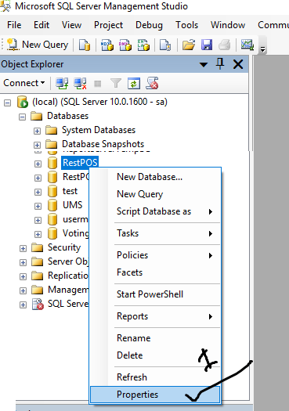

Select **Collation** to your native language -> and Press OK  
Example: For Arabic language: **Arabic_CI_AS_KS_WS**

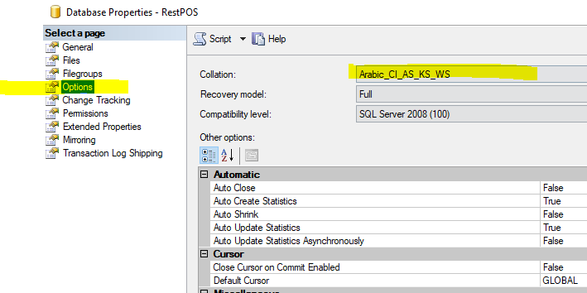

Step: 2

Now open your project with visual studio -> Solution Explorer -> Open **App.config** file and change yellow color info   
  
**For SQL server Authentication configuration**   
<?xml version="1.0" encoding="utf-8" ?>

<configuration>

<configSections>

</configSections>

<connectionStrings>

<add name="RestPOS.Properties.Settings.RestPOSSQLConnectionString"

connectionString="Data Source=(local);Initial Catalog=RestPOS; User ID=sa;Password=sapass123!" providerName="System.Data.SqlClient" />

</connectionStrings>

<startup>

<supportedRuntime version="v4.0" sku=".NETFramework,Version=v4.5" />

</startup>

</configuration>

Example:   
"Data Source= **(local)** /or **.\\SQLEXPRESS** or your DB IP address (**127.0.0.1**) or your SQL server name;   
Initial Catalog= Database Name;   
User ID= DB User ID; // sa  
Password= DB user password";  
**Change your server info and Save**

**For Windows Authentication connection Strings**  
==============================================  
 <connectionStrings>  
 <add name="RestPOS.Properties.Settings.RestPOSSQLConnectionString"

connectionString="Data Source=.\**SQLEXPRESS**; Initial Catalog= RestPOS; Integrated Security=true" />  
 </connectionStrings>

If you want to run software without using visual studio   
Open file -> \RestPOS_MS_SQL\RestoPOS_Source_code\RestPOS\bin\Debug   
**RestPOS.exe.config**  and change above info

Thanks.

**DynamicSoft**

Please don’t forget to Rate us to get Support <http://codecanyon.net/downloads>